Ideation Phase
Brainstorm & Idea Prioritization Template

Date | 05 July 2026
Project Name | Cab booking
Maximum Marks | 4 Marks

Brainstorm & Idea Prioritization Template:
Brainstorming provides a free and open environment that encourages everyone within a team to participate in the creative thinking process that leads to problem solving. Prioritizing volume over value, out-of-the-box ideas are welcome and built upon, and all participants are encouraged to collaborate, helping each other develop a rich amount of creative solutions.

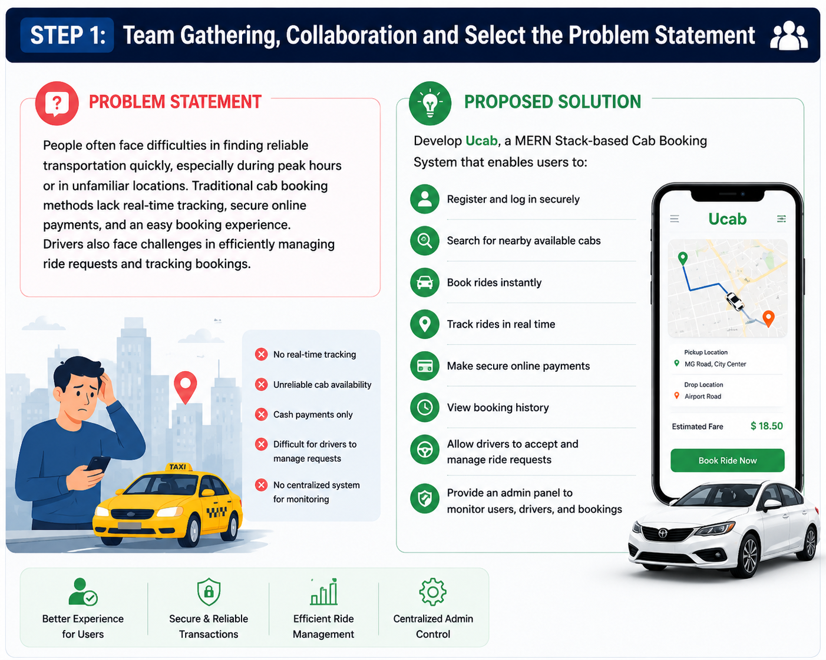
Problem Statement
People often face difficulties in finding reliable transportation quickly, especially during peak hours or in unfamiliar locations. Traditional cab booking methods lack real-time tracking, secure online payments, and an easy booking experience. Drivers also face challenges in efficiently managing ride requests and tracking bookings.

Proposed Solution
Develop Ucab, a MERN Stack-based Cab Booking System that enables users to:
- Register and log in securely
- Search for nearby available cabs
- Book rides instantly
- Track rides in real time
- Make secure online payments
- View booking history
- Allow drivers to accept and manage ride requests
- Provide an admin panel to monitor users, drivers, and bookings
Brainstorm, Idea Listing and Grouping
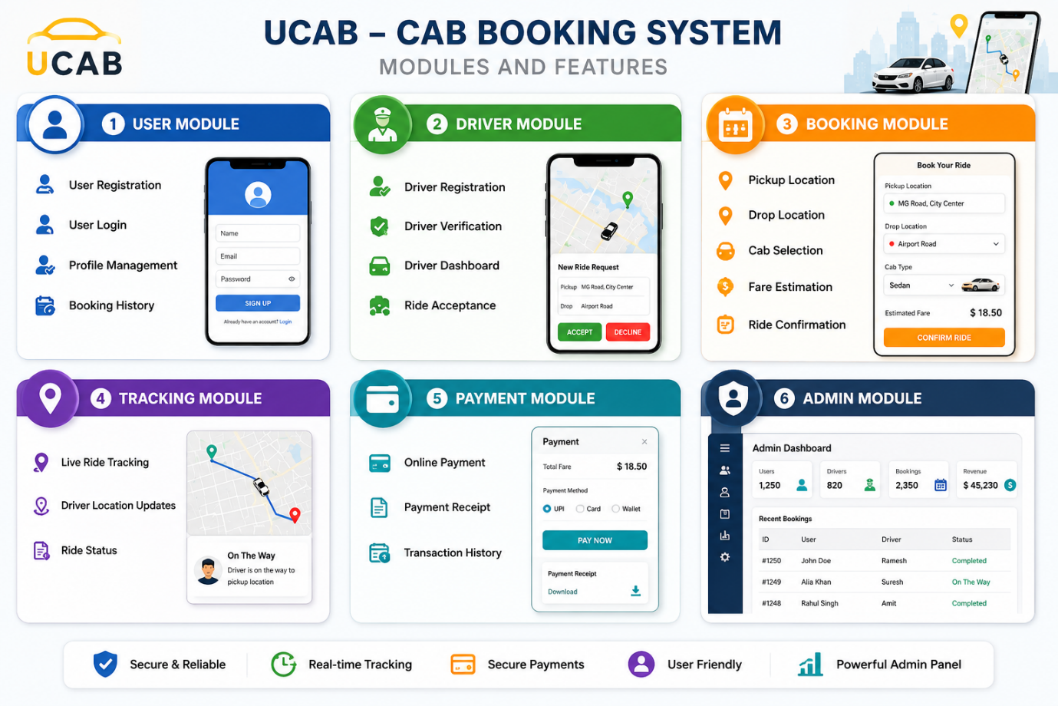
User Module
- User Registration
- User Login
- Profile Management
- Booking History
Driver Module
- Driver Registration
- Driver Verification
- Driver Dashboard
- Ride Acceptance
Booking Module
- Pickup Location
- Drop Location
- Cab Selection
- Fare Estimation
- Ride Confirmation
Tracking Module
- Live Ride Tracking
- Driver Location Updates
- Ride Status
Payment Module
- Online Payment
- Payment Receipt
- Transaction History
Admin Module
- Manage Users
- Manage Drivers
- Manage Bookings
- Generate Reports
Idea Prioritization
Feature | Importance | Feasibility | Priority
User Registration & Login | High | High | ⭐⭐⭐⭐⭐
Driver Registration | High | High | ⭐⭐⭐⭐⭐
Cab Booking | High | High | ⭐⭐⭐⭐⭐
Fare Estimation | High | Medium | ⭐⭐⭐⭐
Ride Tracking | High | Medium | ⭐⭐⭐⭐
Online Payment | High | Medium | ⭐⭐⭐⭐
Booking History | Medium | High | ⭐⭐⭐⭐
Admin Dashboard | Medium | High | ⭐⭐⭐⭐
Driver Verification | Medium | Medium | ⭐⭐⭐
Reports & Analytics | Low | Medium | ⭐⭐⭐

Expected Outcome
- Develop a complete MERN Stack Cab Booking System.
- Implement secure JWT authentication with role-based access.
- Build responsive user, driver, and admin dashboards.
- Enable cab booking, ride tracking, and payment management.
- Gain practical experience in React.js, Node.js, Express.js, MongoDB, REST APIs, and full-stack application development.
